COMMERCIAL OFFER

Date:
LOI №
From: Shanghai Enhof Trading Co. LTD
To: END BUYER

We, Shanghai Enhof Trading Co. LTD, hereby declare that we are ready and able to supply the following dump truck as specified below.
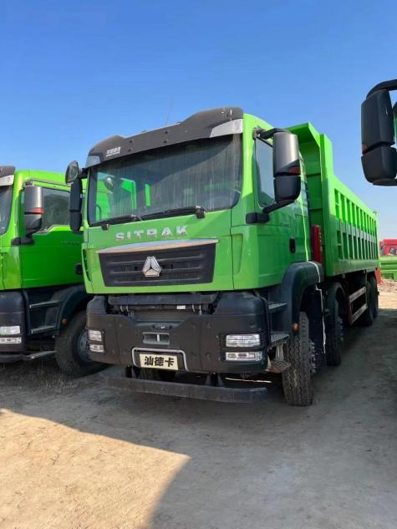

Name of truck: SITRAK G7 Dump Truck
Type: 8x4
Horse power: 400hp
Body size: 10.2x2.55x3.4 m
Cargo size: 7.2x2.35x1.5 m
Load: 40000 kg
Origin: China
Quantity：2 pieces
Incorterms: CIF
Payment: TT
Price: 633080RMB or 6800000Ruble. (RMB rate: 10.7411 Rubles)

Best regards
Name
Director
Shanghai Enhof Trading Co. LTD
E-mail: info@enhofchina.com
Moble:

SELLER'S INFORMATION

Company name | Shanghai Enhof Trading Co., Ltd.
Company Address | 2128, Area M, Building 1, No. 15, Lane 588, Zhangliantang Road, Qingpu District, Shanghai, China
Taxpayer number | 91310000MA1J2YPU4N
Tel/Fax | +862133550330
Mobile | +8615821162550
E-mail | info@enhofchina.com
Web | enhofchina.com
Director | Name
Bank name  Chinese name | The Industrial And Commercial Bank Of China, Shanghai Songjiang Sub-Branch  中国工商银行股份有限公司上海市松江支行
Bank address | No. 218 Zhongshan Two rd. Songjiang District, Shanghai, China, 201600
Bank telephone | +86 21 37000175, +86 21 37000177, +86 21 37701160 mr. Lu
Bank officer name: | 齐老师 Teacher Qi , Mr. Lu
SWIFT | ICBKCNBJSHI
Beneficiary name  Chinese name | Shanghai Enhof Trading Co., Ltd.  上海意芙贸易有限公司
Beneficiary bank account (RMB) | 1001739609000175633

